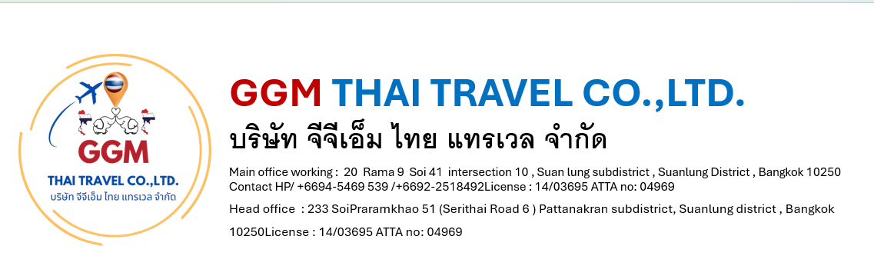
BANGKOK -KHAOKHO 5day4night (Private)
Tour Code: B-KHO-05
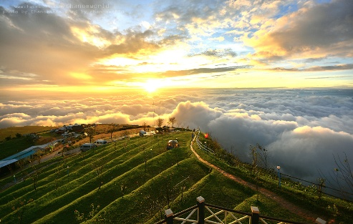
Day 1: Arrive -Bangkok
- Meet and great proceed visit to famous, 4face buddha, Joo fair Night market Dinner by own

Day 2: Bangkok – Phu Tabbreak -Khaokho ( B.L.D)
- Breakfast, Enroute to Petchabun province by van only for approximately 5 hrs journey Visit to Wat Pratat Phasonkaew , Pino late & café enjoy western set lunch
- (complementary one Thai tea or coffee drink) Over night at Khao khao

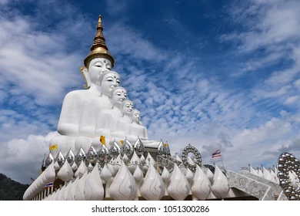
Day3 :PHU Tabbreak-Khaokho ( B./L-D)
Early morning at 5 am, Transfer and arrive Phu Tabbreak embrace Breakfast simple Arrive at foot Mount Phu Tab break , proceed to transfer to hill by open truck and embrace the beauty of the sea of fog at hill point as Phi tub berk is famous for its cloud -like scenery in the between the mountains , Phuhin long kra National park , after Transfer to Wat Khiri Wong which is the located on the Dao-wa Ding hill Evening enjoy night Lomsak street for local food testing own on leisure
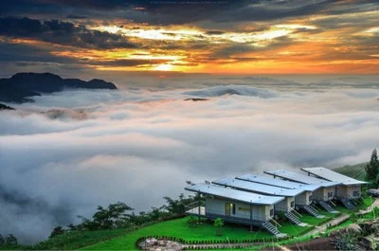
Day 4 : Khao-Kho -Bangkok ( B/L/D)
- Breakfast simple, Visit to Khao Kho wind farm, after transfer back to Bangkok, Shopping Platinum mall, Asiatique River front Night Market

Day 5: Bangkok-Dept (Breakfast)
- Free leisure time for Shopping Platinum mall. Big C supermarket and send to Airport

